# 

# ANALYSIS OF SEED SOWING MECHANISMS IN AGRICULTURAL ROBOT

Seminar Report

**Submitted by**

**POOLA ROHITH**

*In partial fulfilment of the requirements for the award of the degree of*

**Bachelor of Technology**

*in*

**Mechanical Engineering**



Department of Mechanical Engineering

NATIONAL INSTITUTE OF TECHNOLOGY CALICUT

NIT CAMPUS PO, CALICUT

KERALA, INDIA 673601

April 2021

**CERTIFICATE**

This is to certify that the report entitled “**ANALYSIS OF SEED SOWING MECHANISMS IN AGRICULTURAL ROBOTS**” is a bonafide record of the **Seminar** presented by **POOLA ROHITH** (*Roll No*.: **B180712ME**), in partial fulfilment of the requirements for the award of the degree of **Bachelor of Technology** in **Mechanical Engineering** from **National Institute of Technology Calicut**.

## Faculty-in-charge

## (ME4097 – Seminar)

## *Dept. of Mechanical Engineering*

***Professor & Head***

## *Dept. of Mechanical Engineering*

*Place:* NIT Calicut

*Date*: 18-April 2021

Department seal

**ABSTRACT**

Agriculture is one of the important sectors in Indian economy. In agriculture Sowing seeds is one of the important and laborious activity that requires lot of physical effort and man power. It can be replaced by a Robot which is capable of sowing seeds for any type of crop and any size of seed. Developing a mechanism for planting seeds such that they are spaced uniformly and the space between them can be adjusted to any required length, which makes the Robot more reliable. Developing a Robot with suitable mechanism which can be controlled by an unskilled worker reduces human effort and labour. Also, increases sowing efficiency and accuracy

**Key words:** Agricultural Robot, Seed, Planting, Sowing.

**CONTENTS**

List of Figures ii

List of Tables iii

1. Introduction 1
   1. Preamble 1
   2. Problem Description 1
2. Review of Literature 2
   1. Significance of Models 2
      1. Design and Fabrication of Seed Sowing Machine 2
      2. Solar Operated Automatic Seed Sowing Machine 2
      3. A Review on Multi-Seed Sowing Machine 3
3. **Objectives 5**
4. **Factors affecting Germination and Growth 6**
5. **Design and Working of Seed Sowing Machines 8**
   1. Individual Seed Sowing Mechanism 8
      1. Storage Tank 8
      2. Rotating disc, Seed buckets, Metering device 8
      3. Working 9
   2. Multi-Seed Sowing Mechanism 10
      1. Storage Tank 10
      2. Discs, Cylinder and Moving strips 11
      3. Base plate and furrow openers 12
      4. Assembly and Working 13
6. **Results and Discussions 14**
   1. Results 14
   2. Analysis 15
      1. Advantages of Seed sowing machines 15
      2. Drawbacks 15
7. **Conclusions and Scope of Future work 16**
   1. Conclusion 16
   2. Scope of Future work 17

References 18

**LIST OF FIGURES**

5.1 Storage Tank 1 08

5.2 Rotating disc & Metering device 09

5.3 Assembly 1 10

5.4 Storage Tank 1 10

5.5 Cylinder 11

5.6 Discs 11

5.7 Moving strips 11

5.8 Base plate 12

5.9 Furrow opener 12

5.10 Assembly 2 13

**LIST OF TABLES**

4.1 Different Seed sizes 06

4.2 Optimal parameters for planting seeds 07

6.1 Results achieved by Robot 14

**CHAPTER 1**

**INTRODUCTION**

* 1. **PREAMBLE**

Agriculture is the backbone of India. Agriculture is one of the most important sectors in Indian economy and agriculture plays a vital role for sustainable growth of development in India. About 75% people are living in the rural area and are still dependent on agriculture. About 43% of geographical area is used for agricultural activity. India is the second most populated country in the world and its population is increasing day by day hence the demand for food is also increasing. In order to meet the demand, the production should also be increased significantly which can’t be accomplished by human alone.

Different activities in agriculture are performed in a large scale and they require lot of physical effort and man power. Most of the activities in agriculture are very tedious and does not required skilled labour. These tasks in agriculture can be accomplished by Machines. They can perform repetitive tasks with more accuracy and efficiency. The energy required for the robots is very less as compared with other machines like tractors or any agriculture instrument, also the required energy can be generated from the solar energy which is found abundantly in nature.

* 1. **PROBLEM DESCRIPTION**

One of the important activities in agriculture is Sowing of seeds. In general, the manual method of planting seeds results in low seed placement, less spacing efficiencies and serious back ache for the farmer and it requires more man power to complete the task within stipulated time which will be costlier. Also, there is a chance of wastage during manual planting. Availability of sufficient labours will also be a constraint for performing this task in a large scale.

This task can be easily accomplished by robots and they are very useful in the field of agricultural as they can reduce the human effort to a great extent and reduces the dependency on the labour too. Usually, the machine which needs to perform the task of seed sowing can be designed in different ways depending on the type of field, crops, seeds and different factors which affect the sowing of the plants. But, designing a mechanism which is capable of sowing seeds of any types of crops at any required distancing between the plants, can sow the seeds at variable depths as the optimal depth of planting of seeds various from crop to crop, will be more useful and reliable

**CHAPTER 2**

**REVIEW OF LITERATURE**

**2.1 SIGNIFICANCE OF MODELS**

The following report is a cumulative study of various scientific research papers which are based on designing of different seed sowing mechanisms and their implementation in the field.

* + 1. **Design and Fabrication of Seed Sowing Machine. [1]**
* A detailed analysis was made on different size (diameter) of the seeds and their range, which is crucial in building a generalized mechanism.
* The data representing various optimal depths for corresponding crops have been collected and utilized in implementing the idea.
* The researchers have considered lot of mechanical factors which influences the seed germination and proposed optimal idea that improves the seeding conditions.
* A metering device is introduced in the mechanism to keep track on the count of planted seeds
  + 1. **Solar Operated Automatic Seed Sowing Machine. [3]**
* The Seed sowing mechanism is designed to have a cylinder with spikes for tilling and holes in between to drop the seeds.
* The mechanism is designed in such a way that it can be coupled to the same motors which are used for locomotion to save the power consumption.
* They have selected a sustainable source of energy (Solar) for power. Solar panels are incorporated in the Robot for conversion of Solar energy to electrical energy.
  + 1. **A Review on Multi-Seed Sowing Machine. [4]**
* The researchers have designed the seed sowing mechanism to have the capability of sowing multiple seeds at the same time.
* Initially the required distance between the seeds should be adjusted manually, which will be followed by the robot during sowing.
* The multiple seed sowing mechanism reduces the time required to complete the seeding in the entire field.
* These mechanisms ensure higher accuracy and uniformity in sowing and provides greater compaction over the seeds.

**CHAPTER 3**

**OBJECTIVES OF A SEED SOWING MACHINE**

For a machine to be reliable in the place of human beings it should possess certain characteristics with which it will be capable of accomplishing the particular task.

The important characteristics and objectives of a seed sowing machine are its design which should be Feasible for Locomotion through the lanes in the fields which ensures the dimensions of the robot to be compatible with the lane distancing in several fields. If the machine is designed is a such a way that it can cover multiple lanes at the same time it will be more useful and efficient with respect to both fuel and time.

The mechanism which sows the seeds inside the soil should be designed optimally so that it can penetrate through the ploughed sand easily. As the distance of planting adjacent seeds differ from crop to crop, the mechanism should have adjustable distancing facility and adjustable depth of sowing seeds for ensuring optimal conditions to assist germination which varies from crop to crop. This gives an added advantage of the mechanism so that it can be used to any type of crop and at any type of field. The designed mechanism should be capable of maintaining uniformity in the placement of adjacent seeds and ensure proper compaction over the seeds.

**CHAPTER 4**

**FACTORS AFFECTING GERMINATION**

Important factors which affect seed germination and growth are

* Uniformity in the depth of placement of seed.
* Uniformity in the spacing between seeds in a row for better growth of roots
* Proper compaction of soil over the soil.
* Loose soil should be prevented.

All these factors vary from crop to crop. Hence, the design should be simplified and components are selected to suit the need of the corps. The Robot should be capable of adjusting these parameters depending on the plant being planted. Seed planter plays vital role in manipulating the physical environment and ensuring compaction of soil.

|  |  |
| --- | --- |
| **SEED** | **SIZE (Diameter, mm)** |
| Arugula | 2.5 |
| Beet | 7.5 |
| Broccoli | 3.5 |
| Cabbage | 3.5 |
| Carrot | 3.5 |
| Cauliflower | 3.5 |
| Corn | 13.5 |
| Cucumber | 9 |
| Lettuce | 6 |
| Okra | 7.5 |
| Onion | 6 |
| Pea | 10 |
| Radish | 4 |
| Sun flower | 2.5 |

Table 4.1 Different Seed sizes

|  |  |  |
| --- | --- | --- |
| **SEED** | **SPACING BETWEEN PLANTS (cm)** | **PLANTING DEPTH (Diameter, mm)** |
| Asparagus | 30 | 2.5-4 |
| Beet | 3-5 | 1.5 |
| Broccoli | 45-60 | 0.5-1.5 |
| Cabbage | 45 | 0.5-1.5 |
| Carrot | 3-5 | 1.5 |
| Cauliflower | 45-60 | 0.5-1.5 |
| Corn | 15-25 | 2.5 |
| Okra | 30 | 2.5 |
| Onion | 5-8 | 1.5-3 |
| Pepper | 60 | 1.5 |
| Potato | 25-30 | 10 |
| Radish | 2.5 | 1.2 |

Table 4.2 Optimal parameters for planting seeds

The Table 4.1 and Table 4.2 provides the values of optimal sizes of different seeds and optimal distances and depth for planting respectively. By maintaining the above-mentioned factors properly and planting the seeds uniformly ensures proper germination and growth conditions which further gives good yield of the crop.

**CHAPTER 5**

**DESIGN AND WORKING OF SEED SOWING MECHANISMS**

* 1. **DEVELOPMENT OF INDIVIDUAL SEED SOWING MECHANISM** 
     1. **Storage tank**

The machine consists of a Storage device and it is designed such that it has the optimal seed carrying capacity and its overall weight can be sustained by the robot. Storage tank is a stationary part of the robot. Seed sowing disc is arranged to the bottom of this tank. This disc is used in the distribution of the seeds. The whole mechanism is designed such that only one seed falls from the tank for every complete rotation of the disc. Also, number of seeds coming from tank is varied according to requirements by varying the motor speed. This disc evenly opens the way to seed so that planting of seeds can be achieved accurately and smoothly.



Fig 5.1 Storage Tank

* + 1. **Rotating disc, Seed buckets and Metering device**

The Disc is used to hold the buckets along its circumference in which seed is held in every rotation. It is attached at the bottom of the tank and one seeds is allowed to fall for one rotation of wheel. In the Fig 5.2 includes the seed sowing disc. The buckets resemble the shape of Pelton buckets. The buckets are attached to the disc, their size is varied depending on the diameter of the seed.



Fig 5.2 Rotating disc & Metering device

Fig 5.2 shows the seed metering device attached to the rotating disc, which measures the amount of seeds being planted in the soil. It also maintains the required level of the sand in the tank. Metering device is necessary to track the amount of seeds being planted and also detects if the tank gets empty. It is also used to get the distance at which seeds can be sowed. Hence, only required amount of seed will fall for every rotation of the wheel.

* + 1. **Working of the mechanism**

Fig 5.3 represents the overall assembly of the individual seed sowing mechanism. The task of planting seeds is achieved by rotating the disc with an electric motor and one seed is allowed to fall from the into the bucket one for every rotation. When the Bucket holding seed comes to the bottom of the disc the seed is dropped into the sand and this rotation is continued which continues the sowing process. Distance between each seed can be varied by changing the motor RPM. The depth of planting can be varied by varying the diameter of the rotating disc. Hence, the seed planting activity is accomplished.



Fig 5.3 Assembly 1

* 1. **DEVELOPMENT OF MULTI-SEED SOWING MECHANISM**
     1. **Storage tank**

The storing tank is used for storing seeds. There are two main compartments in it. One for seeds and the other compartment is provided for fertilizer. The tank is designed to have a capacity of holding the weight of 50kg seed and fertilizer. The tank has small hollow tubes at the bottom from which seeds are dropped.

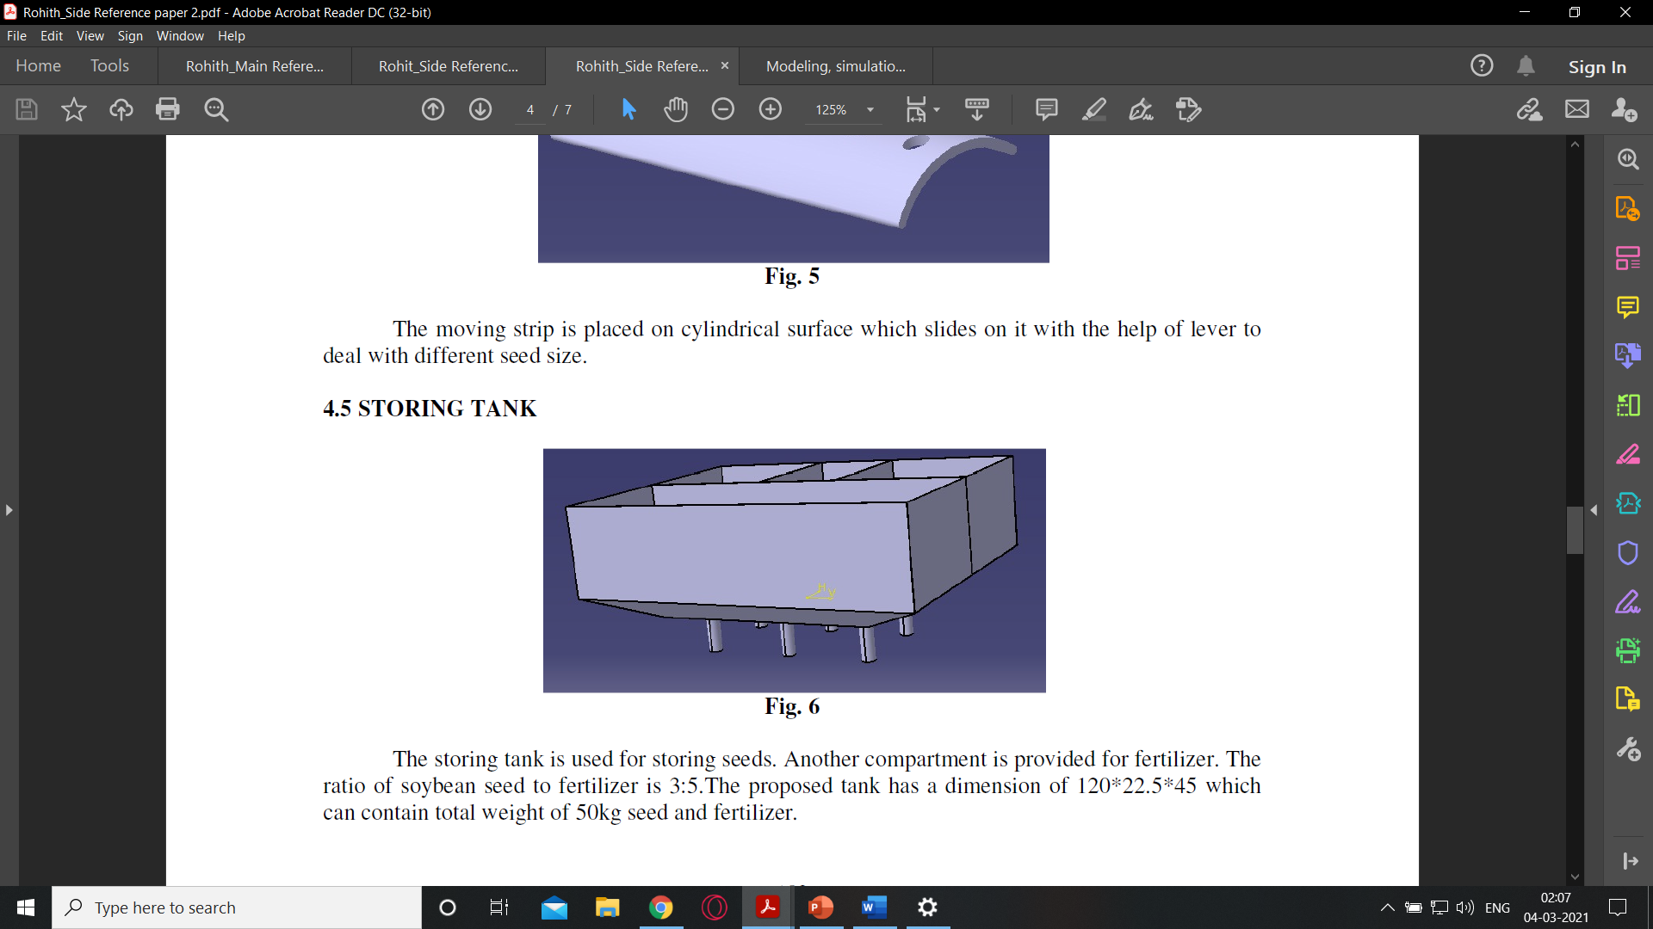

Fig 5.4 Storage Tank

* + 1. **Discs, Cylinder and Moving strips**

The Cylinder (Fig 5.5) consists of holes, which are used to drop the seeds collected from the storage tank through these holes. Multiple discs (Fig 5.6) are coupled to a shaft and inserted in the cylinder which rotates freely inside it. The seeds are dropped in between these discs and it ensure the smooth flow of the seeds during sowing through the cylinder. The moving strip (Fig 5.7) is placed on cylindrical surface which slides on it with the help of lever to deal

with different seed size.

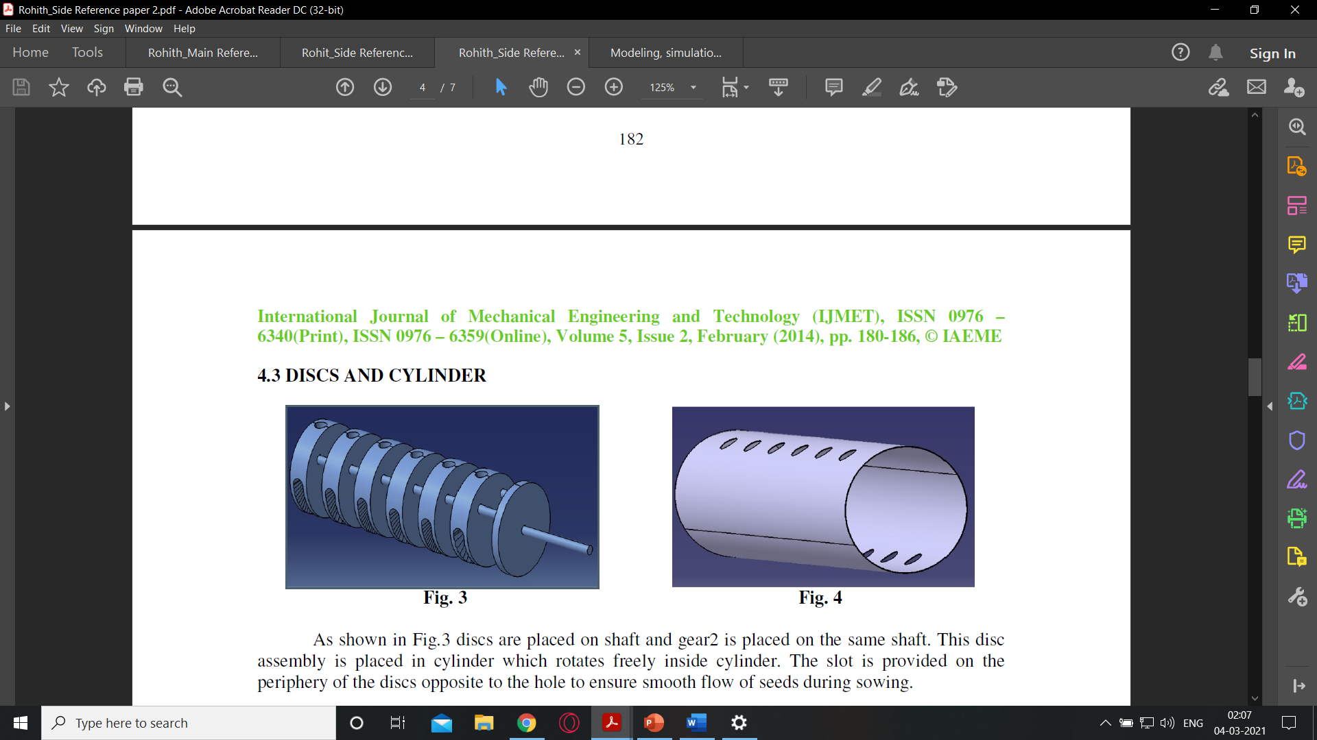

Fig 5.5 Cylinder



Fig 5.6 Discs

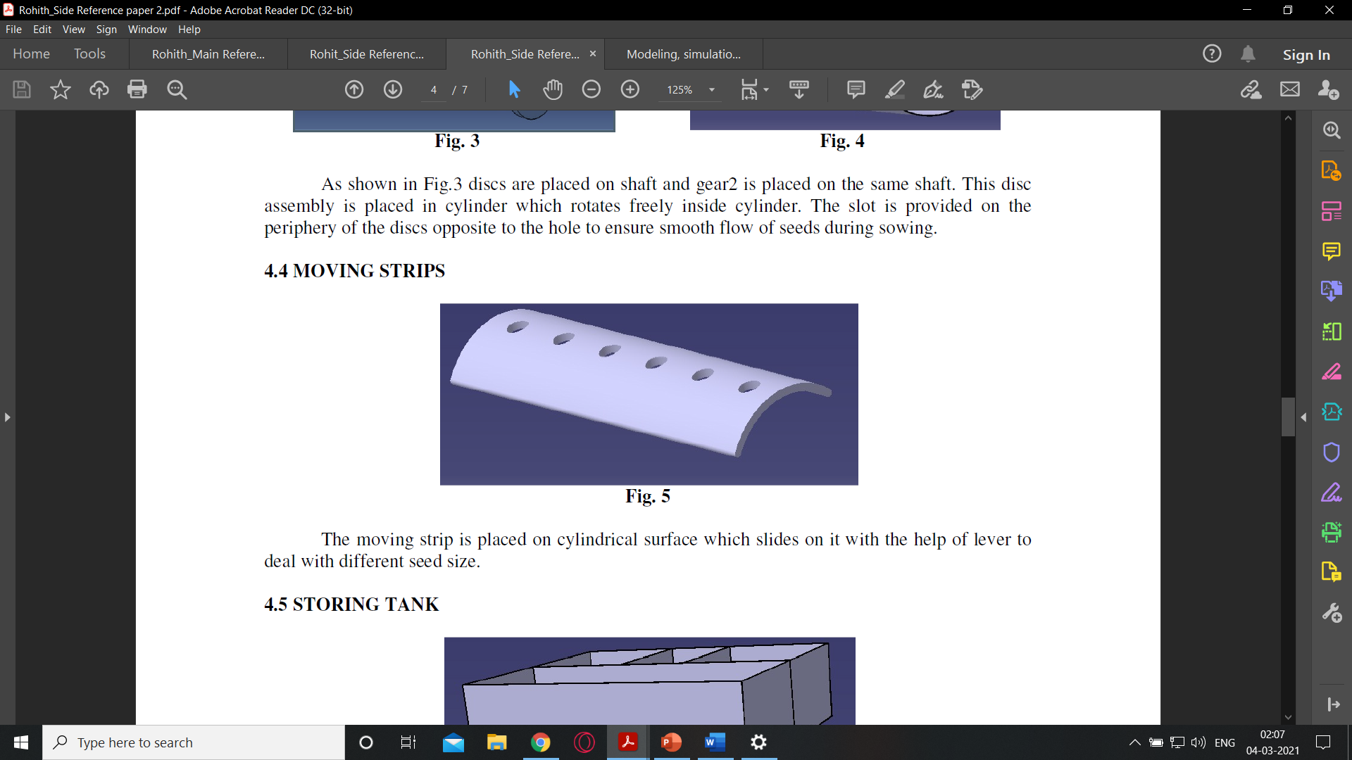

Fig 5.7 Moving strips

* + 1. **Base plate and Furrow openers**

The seeds from the cylinder are dropped on to the Base plate (Fig 5.8) and

Slot1 is provided on the plate for easy moving of pipes (which carries seeds and fertilizer). The furrow openers shown in Fig 5.9 can be moved and fixed on base plate by using nut and bolt arrangement at any position to obtain required row spacing. Thus, by adjusting the distancing between the furrow openers the row spacing is adjusted which will be maintained through out all the rows. The furrow openers are designed to even perform tilling actuation during the actuation.

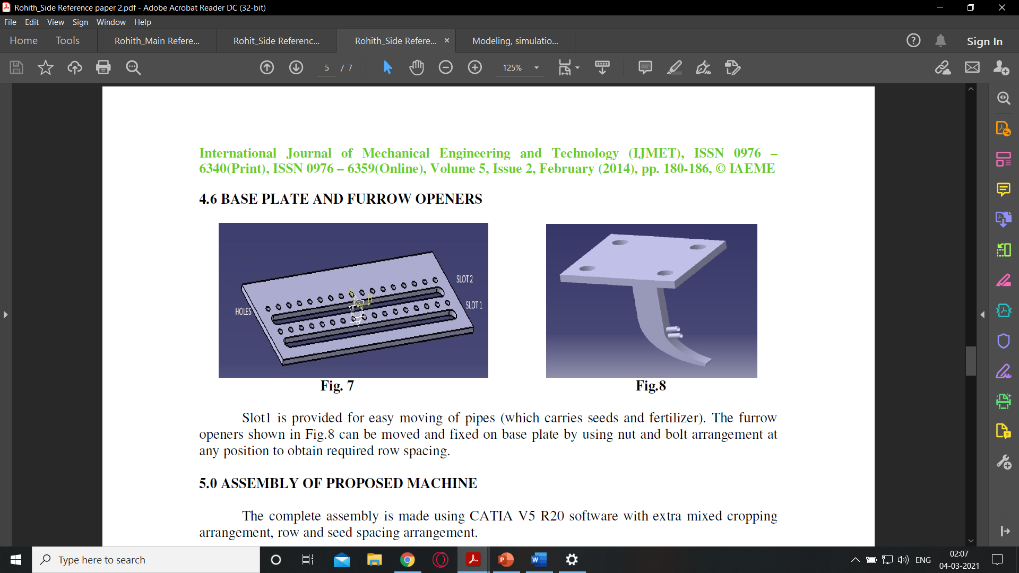

Fig 5.8 Base plate



Fig 5.9 Furrow opener

* + 1. **Assembly and Working**
* The whole assembly of the seed sowing mechanism as shown in Fig 5.10, is mounted to a tractor.
* Due to the motion of the tractor the planter wheels will be rotated which leads to the rotation of gears that are coupled to the cylinder.
* When the holes of the strip and cylinder coincides during rotation seeds are dropped from the tank.
* These seeds are guided to fall on the base plate by the discs inside the cylinder, when the holes come to the bottom of its surface.
* The row distancing is adjusted by changing the distance between furrow openers.
* Finally, seeds are sowed into the soil with precise row to row spacing and good compaction of the soil.

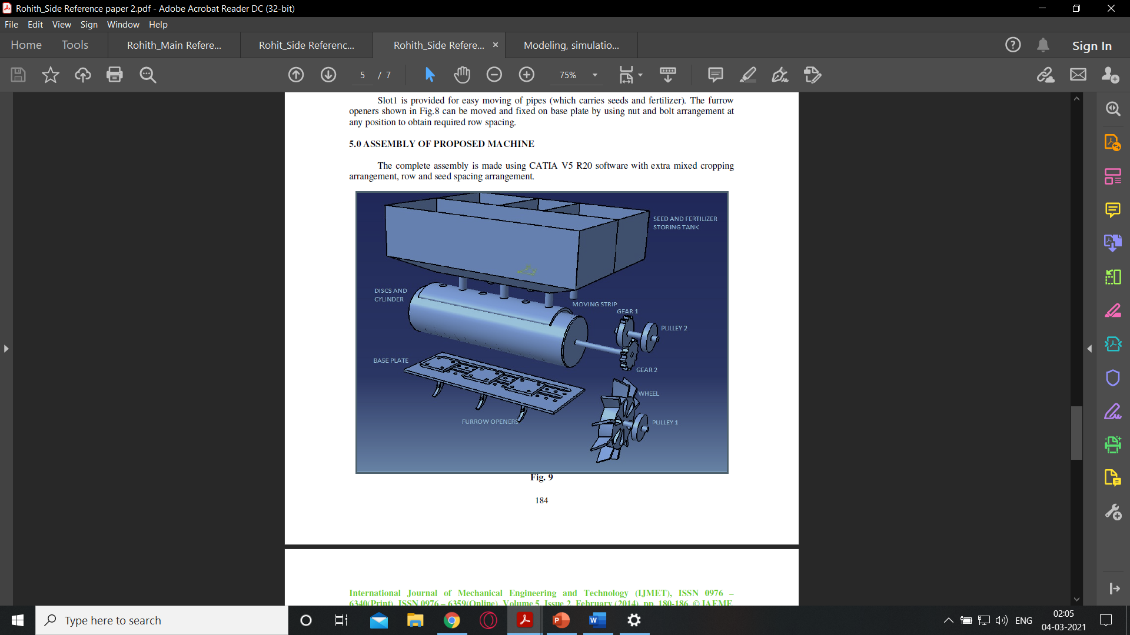

Fig 5.10 Assembly 2

**CHAPTER 6**

**RESULTS AND DISCUSSIONS**

**6.1 RESULTS**

The table 6.1, is the result of using the seed sowing machine [1]. The table shows the accomplishment of the robot for various adjustable distances and depths depending on the corresponding crop with good accuracy and precision.

|  |  |  |
| --- | --- | --- |
| **Vegetable** | **Obtained Distance between plants (cm)** | **Obtained Planting depth (cm)** |
| Asparagus | 26 – 34 | 2 – 5 |
| Beet | 3 – 7 | 2 – 4 |
| Broccoli | 40 – 55 | 1 – 3 |
| Cabbage | 40 – 50 | 1 – 3 |
| Carrot | 3 – 6 | 1 – 3 |
| Cauliflower | 44 – 55 | 1 – 3 |
| Corn | 12 – 25 | 2 – 4 |
| Okra | 28 – 32 | 2 – 4 |
| Onion | 4 – 8 | 2 – 4 |
| Pepper | 55 – 65 | 1 – 3 |
| Potato | 25 – 30 | 5 – 12 |
| Radish | 3 – 5 | 1 – 3 |

Table 6.1 Results achieved by Robot

**6.2 ANALYSIS**

**6.2.1 Advantages of Seed sowing machine**

* Increase in efficiency and accuracy of planting
* Better yield and reliability in crop.
* Increased cropping frequency.
* Highly reliable and cheap with less maintenance.
* Less dependency on the labour.
* Seeds can be planted with higher speed.
* Provides proper compaction over the seeds.
* Consistent row and seed spacing.
* Good uniformity in planting seeds continuously.
* As the depth and the distance between adjacent seeds is adjustable the germination conditions are improved.

**6.2.2 Drawbacks**

The mechanisms that are studied with the reference of [1], [3], has some drawbacks in the design too. As the Seed sowing mechanism in [1], in order change the depth of planting which differs for other crops we should change the whole wheel which is a tedious process for the farmer to maintain different components for different crops.

The mechanism mentioned in the reference paper [3] should be mounted to a tractor for actuation, due to which the space occupied by the tractor wheels are left unused for planting and that will be wasted. The depth of the planting can’t be adjusted optimally due to which we can’t ensure better germination conditions for different crops. If the mechanism is not designed in a generalized way that it can be utilized by any crops then it should be improved to ensure its optimal usage for all types of crops.

**CHAPTER 7**

**CONCLUSIONS AND SCOPE OF FUTURE WORK**

**7.1 CONCLUSIONS**

The usage of machine that consists seed sowing mechanism has greater potential of increasing the productivity of planting when compared to the productivity achieved by human. Robots are most reliable for accomplishing repetitive and tedious tasks. They can be used to achieve flexibility of distancing and controlled depth variation for different seeds.

Machines has very good repeatability, which is the ability to perform repetitive tasks with high accuracy and precision. Human can never have the repeatability of a machine. Robots can maintain constant distancing between the seeds which provides better space for the growth of the roots properly and they can maintain perfect compaction of soil over the seeds after they are planted to the optimal depth, which ensures better conditions for the germination.

Machines save lot of human effort and time required for planting seeds which improves the cropping frequency and they eliminates the labor costs and decreases the dependency on labors. Hence, Robots are the best replacement for human beings in the area of agriculture.

**7.2 SCOPE OF FUTURE WORK**

Robotics in agriculture has high potential in the future. There are so many researches and studies are being conducted in the development of Agricultural Robots. Many research works have the evidence of potential working of robots in the field. But most the existing prototypes are manually controlled or pre-programmed for a particular task. Hence as a part of Industrial revolution 4.0 every sector is moving towards automation and the agricultural sector is one among such sector. There various activities in agriculture which can be automated individually or combinedly. Developing the autonomous agricultural robots is the state of the art in automation era. Many organizations have been working in developing the completely autonomous agricultural Robots.

The potential areas in Agriculture where automation can be achieved are mentioned below.

* Ground tilling.
* Sowing seeds.
* Detection and cleaning of weeds.
* Detection of moisture content in soil.
* Watering of plants.
* Spraying chemicals.
* Harvesting crops.

**REFERENCES**

1. Swapnil, V.T., Kasturi, L.M., Patil, V.G., Patil, N.R., 2017. Design and Fabrication of Seed Sowing Machine. International Research Journal of Engineering and Technology (IRJET). 4 (9), 704 – 707.
2. Martin, V.M., Madesh, A., Karthick, S., Kannan, A., 2015. Design and Fabrication of Multipurpose Sowing Machine. International Journal of Scientific Engineering and Applied Science (IJSEAS). 1(5), 2395-3470.
3. Swetha, S., Shreeharsha, G.H., 2015. Solar Operated Automatic Seed Sowing Machine. International Journal of Advanced Agricultural Sciences and Technology. 4 (1), 67-71.
4. Rohokale, B.A., Shewale, D.P., Pokharkar, B.S., Sanap, K.K., 2014. A Review on Multi-Seed Sowing Machine. International Journal of Mechanical Engineering and Technology (IJMET). 5 (2), 180 – 186.
5. Kawadaskar, A., Dr. Chaudhari, S.S., 2013. Review of Methods of Seed Sowing Concept of Multi-Purpose Seed Sowing Machine. International journal of pure and applied research in engineering and technology. 1(8), 267-276.